EFE GLASS located in Istanbul is a leading Glass Manufacturer was established in 1991 by well-experienced partners.
Our production capacity is 22 tons per day by semi-automatic production with mouth-blown,press and centrifugal facilities.
Main production consists of tabletop glasswares and lighting glasses with treatment techniques and hand-made decorations in different shape and designs such as Lighting Glass, Bathroom Glass Accessoriers, Hand crafted and decorated glasswares for table top, gift items and dinner sets for daily use and also for events and vases for living area and flower industry besides industrial production.
Products
Our trendy collections are presenting a magnificent influence with various options as per its colors and designs, achieves to be recognized in styles baring different atmospheres. Our attractive and hand-made decorated collections are presenting suggestions to remove the monotony and rigidness, bares indispensable lines with its colorful pattern addressing to those active, enthusiastic, rebellious people who always attempt to change.

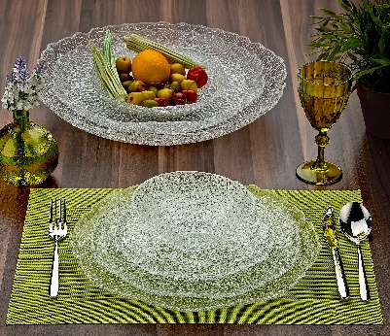 | 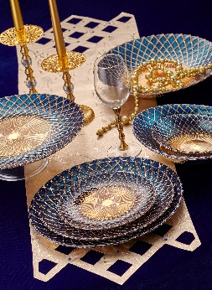 | 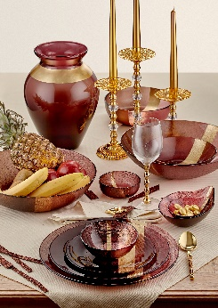 | 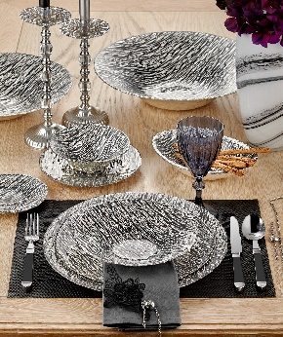

Core Advantages
We are pleased to produce high quality and environmental friendly broad range of glass products in different shape and designs with competitive prices and to export all over the world. Furthermore bespoke projects are meticulously carried out by our Professional team.

NOTES

................................................................................................................................................................................................................................................................................................................................................................................................................................................................................................................................. .................................................................................................................................................................................................................................................................................................................................................................................................................................................................................................................................

