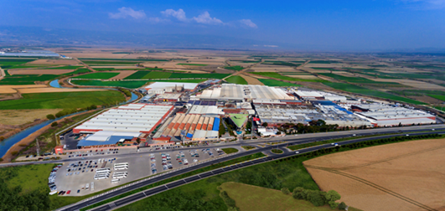
MENDERES TEXTILE
As one of the first integrated plants of the region, Menderes Textile started to be built in 1958 within the borders of Sarayköy district of the province of Denizli under the name of Sarayköy Pamuklu Mensucat. The plant which comprised spinning, weaving and dyeing-finishing departments was put into service in 1962. Targeted to grow with higher investments, the plant which had contributed to the country’s economy for many years became part of the Menderes Textile structure founded by Osman Akça in 1983. Now Menderes Textile, a leader in its industry is the largest vertically integrated home textile factory in Europe.
Operating within the body of Akça Holding; Menderes Textile not only has its 4 main factories which are Yarn, Weaving, Finishing and Confection, it also has many auxiliary facilities including the Cogeneration and Waste Water Treatment facilities. Menderes Textile, with the help of internationally recognized certificates that encompass management, environmental and social system compliances standards, produces the best quality Bed Linen, Quilt Cover, Pillow Cover, Liner Interlining, Meter, Upholstery and Shirting Fabric products with its experienced team, innovative production methods and innovative approach. Menderes Textile converts the world's highest quality cotton into 60.000 kg yarn, 750.000 m² grey cloth, 950.000 m² dyed and printed cloth, 120.000 m² liner-wire and 80.000 sets of sheets and linens in 24 hours.
In Turkey's export sectors, the textile sector takes part amongst the top places with significant share of Menderes Textile. Menderes Textile’s export activities started 26 years ago with just a single country. Now with its 57 years of experience in the textile industry it exports to 41 countries of the world. Throughout the years it’s been exporting, it has become an indispensable supplier of world brands from Europe to North America.
Menderes Textile, which currently employs 4250 people, is a publicly traded company under Borsa İstanbul with a paid capital of TL 250 million and is continuously audited. All the information about the company and its activities can be accessed through public channels in a transparent manner.
Menderes Textile, has a vision “To supply / produce first quality products to the world by using innovative management and inspection systems with international validity. Menderes will continue in line with its vision to be among the institutions that improve the brand's competitiveness. This vision will continue to consistently produce new projects with stakeholders to make it sustainable.

